Lab3 Symbol Synchronization

汪海玉 12011331           张旭东 12011923

## Introduction

In lab2, we ignore the propagation delay to do pulse shaping and matched filtering. However, there are propagation delay in the real channel when the signal transmits. So, we will talk about the basic principle of symbol synchronization and two methods of calculating time delay to get the optimal sampling times.

### Basic principle of symbol synchronization



image-20221029234139265

In the real channel, there are propagation delay so the expression of the receive signal at the receiver can be expressed as following:

$$z\left(t\right)=αe^{jϕ}x\left(t-τ_{d}\right)+v\left(t\right) \text{(1)}$$

The diagram of symbol synchronization is shown below:

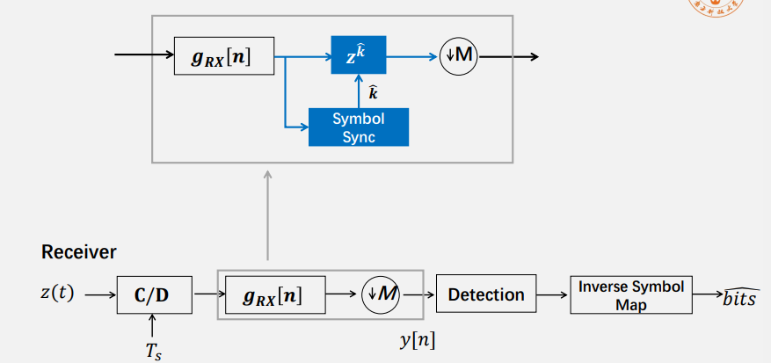

image-20221029235719186

In the previous experience, we use square-root raised cosine function as the pulse function and matched filtering function, which makes the effect of inter symbol interference to reduce to the lowest level. And we do sampling at the maximum point. However, due to the time delay in communication system, the maximum point is shifted. For this, what is needed to do is symbol synchronization. In the next , two methods of symbol synchronization will be introduced, which are $Maximum$ $Energy$ $Algorithm$ and $Early-Late$ $Gate$ $Algorithm$

### Maximum Energy Algorithm

The nature of $Maximum$ $Energy$ $Algorithm$ is to find the most appropriate $τ_{d}$ to make the energy of received signal maximum. The received signal can be expressed as follow:



So the detected signal can be expressed as follow:



The first term denotes the idea value, the second term denotes the effect of inter symbol interference and the third denotes the noise. So the expression of $y\left(t\right)$ is :

$$y\left(t\right)=h\sum_{m=-∞}^{+∞}{s}\left[m\right]g\left(t-mT-τ_{d}\right)+v\left(t\right) \text{(4)}$$

The energy of sampled signal can be expressed as below:

$$\begin{matrix}J\left(τ\right) & =E\left[{\left|y\left(nT+τ\right)\right|}^{2}\right] \\ & ={\left|h\right|}^{2}\sum_{m=-∞}^{+∞}{{\left|g\left(mT+τ-τ_{d}\right)\right|}^{2}}+N_{0} \\ & ={\left|h\right|}^{2}\sum_{m=-∞}^{+∞}{{\left|g\left(mT+τ_{frac}-{\hat{τ}}_{frac}\right)\right|}^{2}}+N_{0}\end{matrix} \text{(5)}$$

Then let its value be maximum to find the most appropriate $τ_{d}$, which makes the energy maximum.



$$E\left[{\left|y\left(nT+τ\right)\right|}^{2}\right]≤{\left|h\right|}^{2}{\left|g\left(0\right)\right|}^{2}+N_{0} \text{(7)}$$

The flowchart of finding the most appropriate $T_{d}$ is showing below:

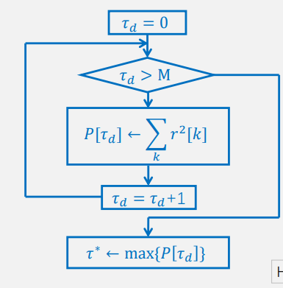

image-20221030005233403

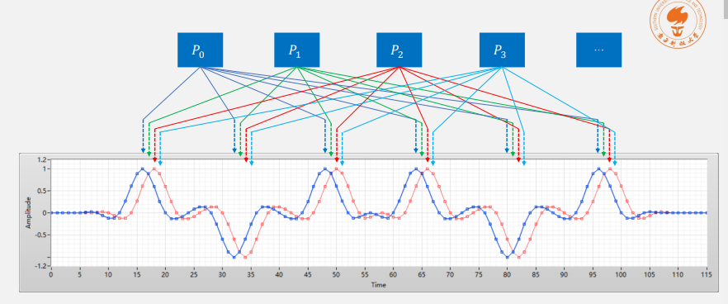

image-20221030005323994

The train of thought to find the most appropriate $τ_{d}$ is to sample the received signal at the original point, which is the maximum point ignoring propagation delay with using square-root raised cosine function. Then do sample in the interval $τ∈[0,T)$ and calculate energy of each. Then, the maximum point is the point whose calculated energy is highest.

### Early-Late Gate Algorithm

Another important method for finding the maximum point in the real channel with propagation delay is $Early-Late$ $Gate$ $Algorithm$. From Maximum Energy Algorithm, the expression of sampled signal is known:

$$J\left(τ\right)=E\left[{\left|y\left(nT+τ\right)\right|}^{2}\right]={\left|h\right|}^{2}\sum_{m=-∞}^{+∞}{{\left|g\left(mT+τ-τ_{d}\right)\right|}^{2}}+N_{0} \text{(8)}$$

The changing rate for it can be expressed as follow:

$$\frac{δ}{δk}J_{δ}\left[k\right]≃\frac{1}{P}\sum_{n=1}^{P-1}{2}Re\left\{\tilde{y}\left[nP+k\right]\left[{\tilde{y}}^{*}\left[nP+k+δ\right]-{\tilde{y}}^{*}\left[nP+k-δ\right]\right]\right\} \text{(9)}$$

When the changing rate equals to $0$ ($\frac{δ}{δk}J_{δ}\left[k\right]=0$), the energy is maximum, which means the point is the maximum point.

The flowchart of finding the point where the changing rate equals to $0$ is showing below:

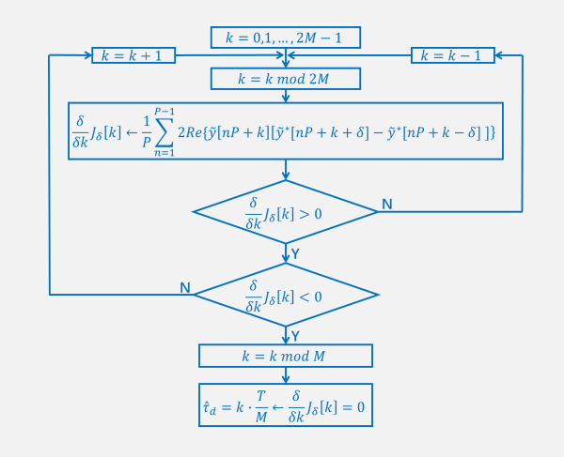

image-20221030012304722

## Result and analysis

### Analysis of Maximum Energy Algorithm

#### Program

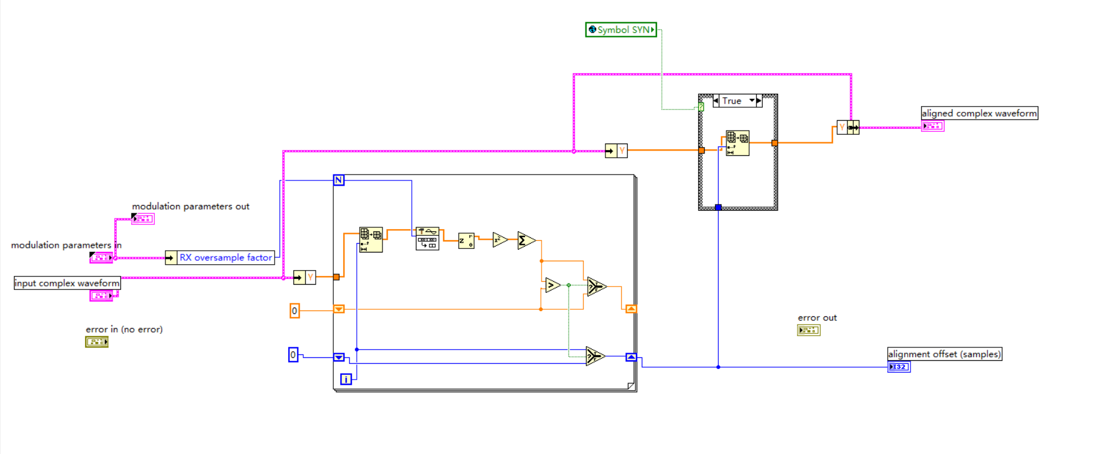

image-20221030100602776

In this part, the first thing is to set the initial time and do the down sampling. Then calculate the sum of square of the amplitude. After that, shift register is used to keep the maximum point. The value in the right shift register is always the maximum. The next structure will control the opening of symbol synchronization.

#### Result

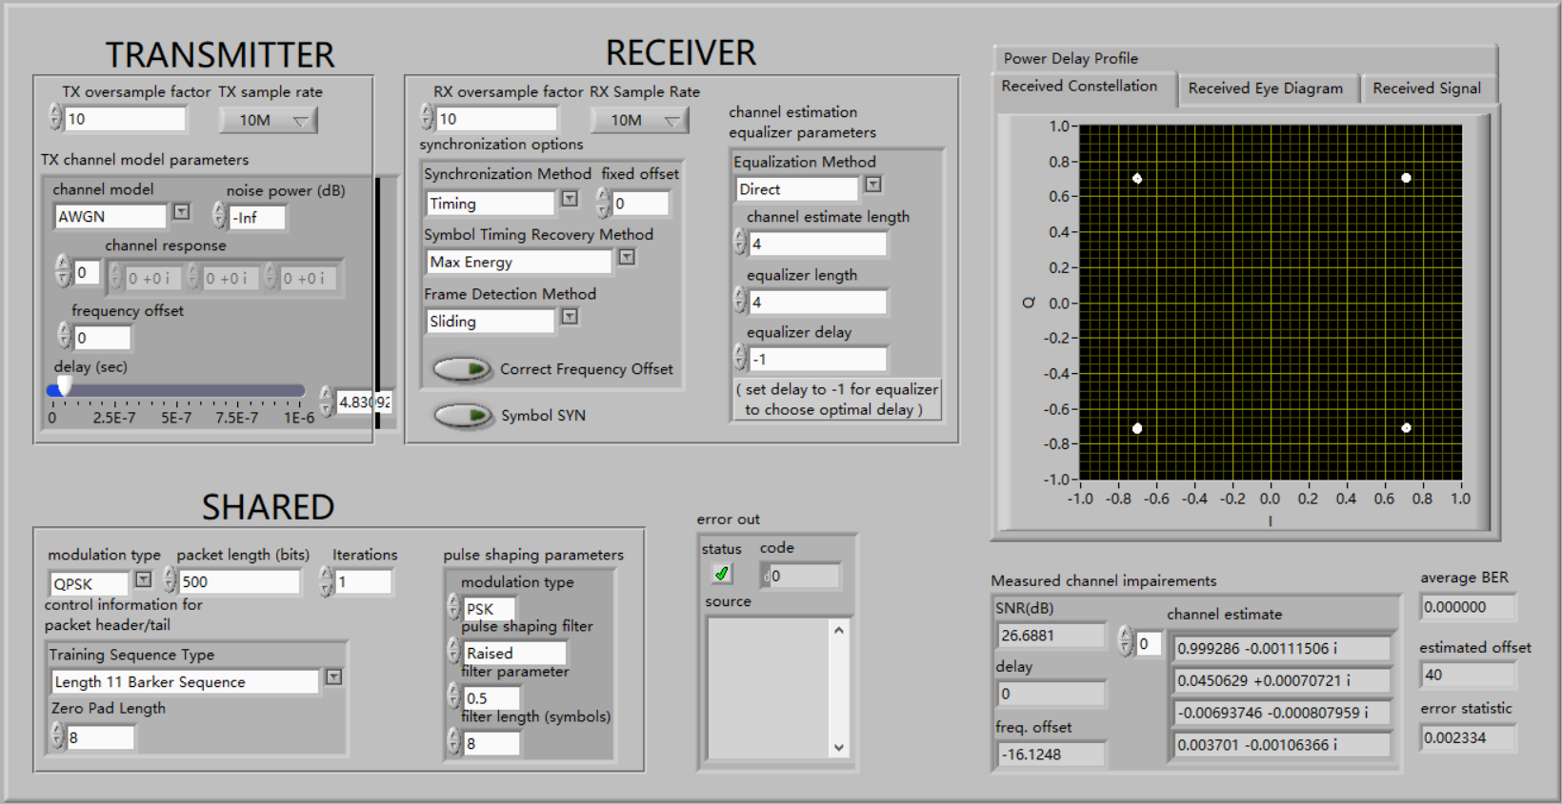

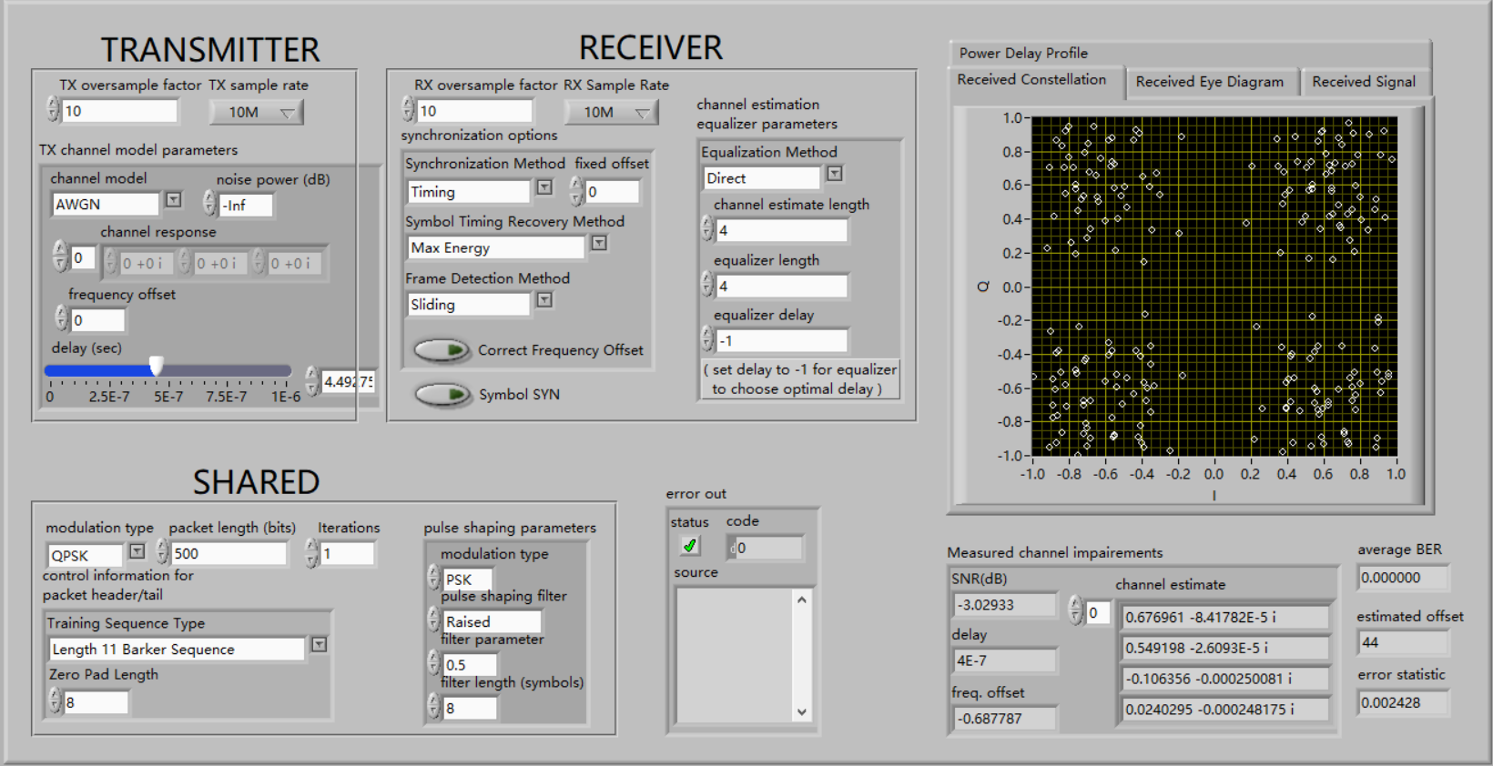

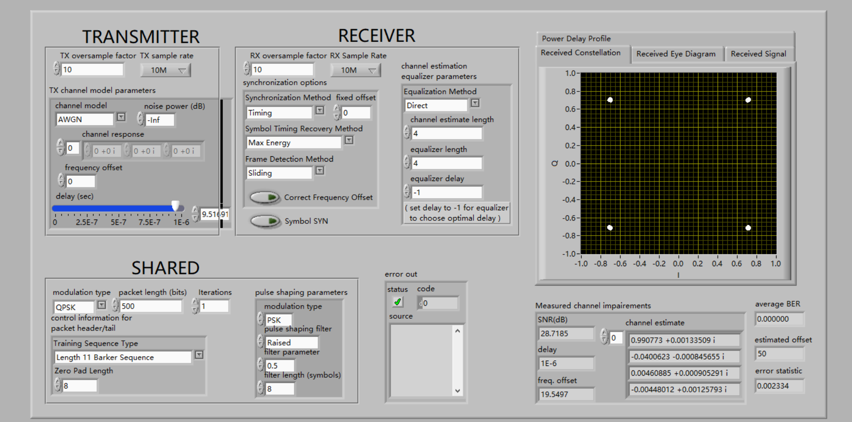

image-20221030101623639

From the above picture, what can be known is that the constellation result will diverge firstly and concentrate then with propagation delay increasing in the model where symbol synchronization closed. This phenomenon is caused by periods of samples.

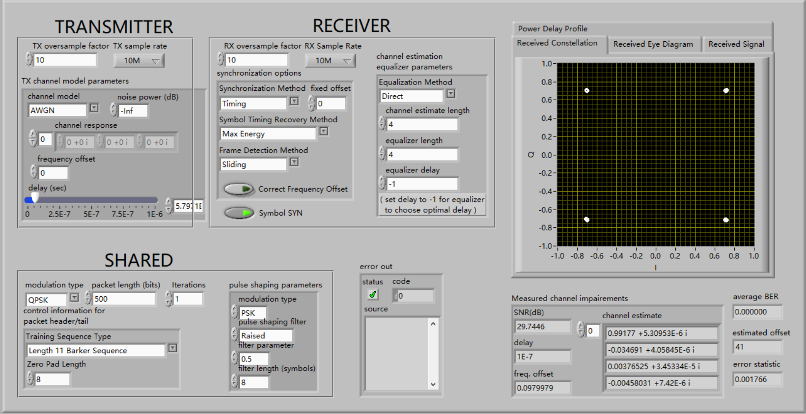

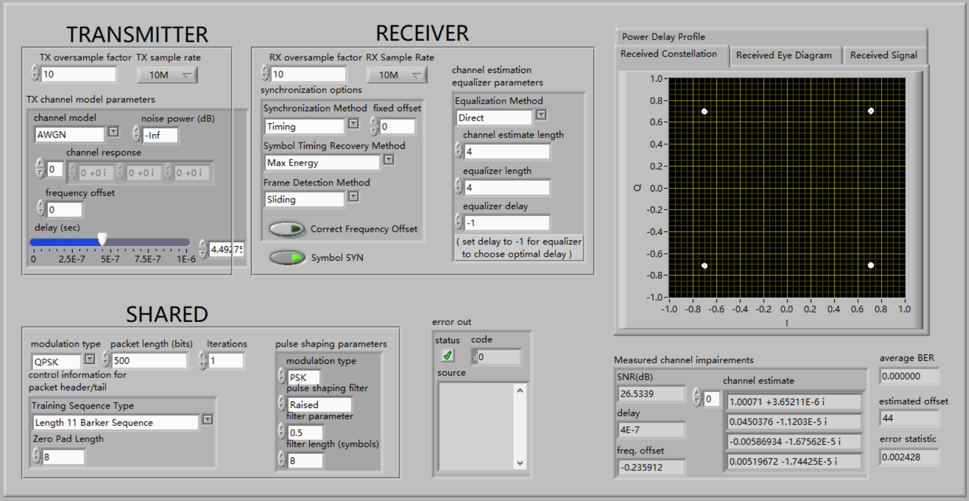

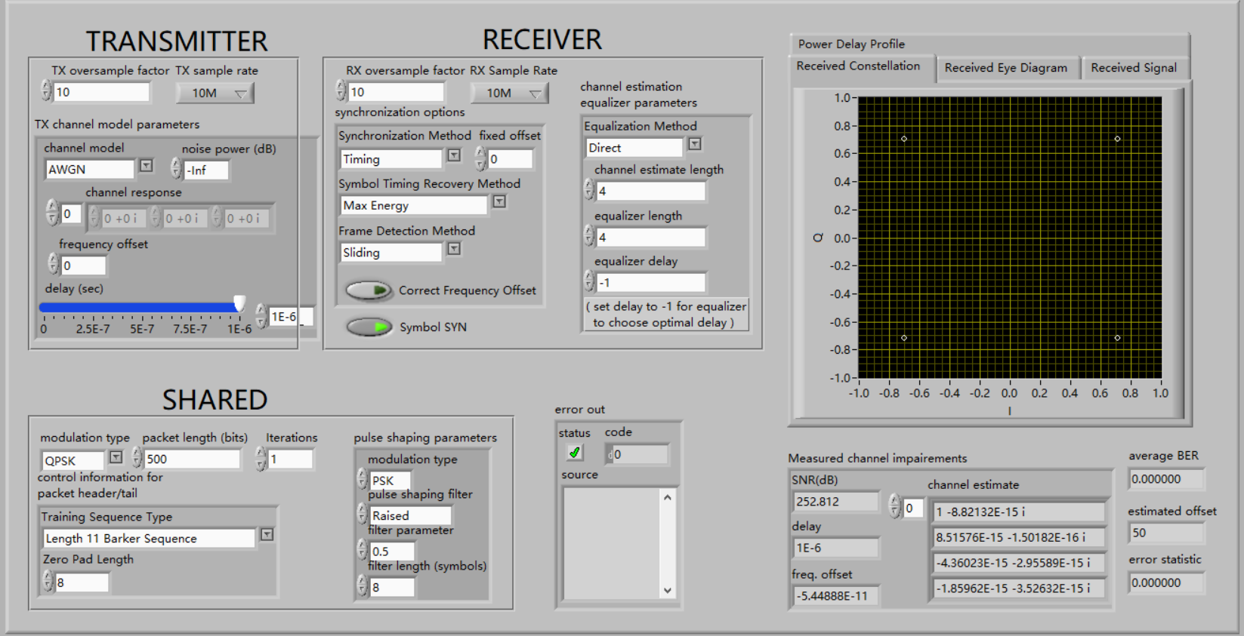

image-20221030101818443

The three pictures are totally different from the last three pictures. It is obvious that the constellation always concentrate with propagation delay increasing in the model where symbol synchronization is open, which means Maximum Energy Algorithm has a very good effect on symbol synchronization.

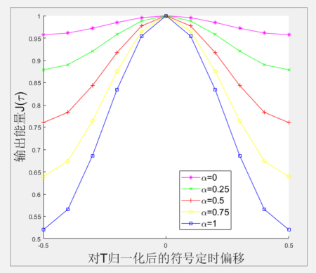

image-20221030103224680

What's more, obviously, with $α$ increasing, the proportion of total energy the energy of middle point occupies becomes larger and larger.

### Accuracy analysis

In this part, the relationship between oversample factor, delay and the sample rate will be discussed.

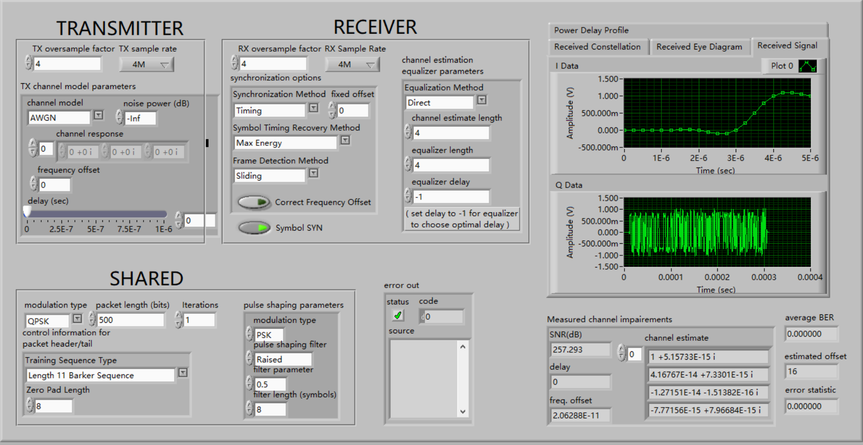

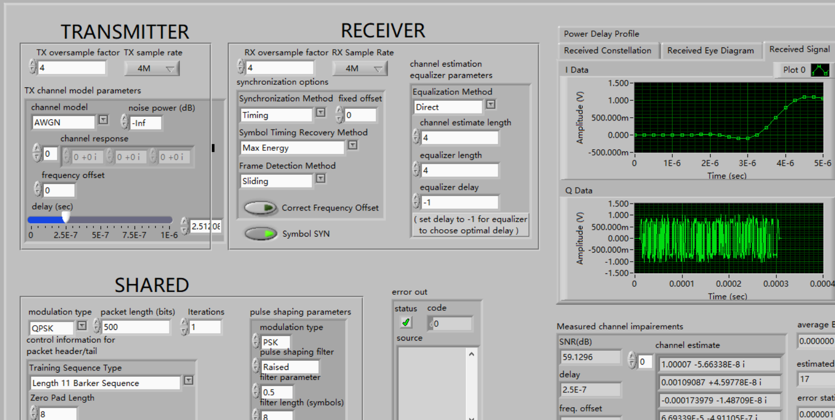

What is easy to find is that the signal is just the same sample signal with propagation delay $0$ and $25μs$, which is correct according to the theory.

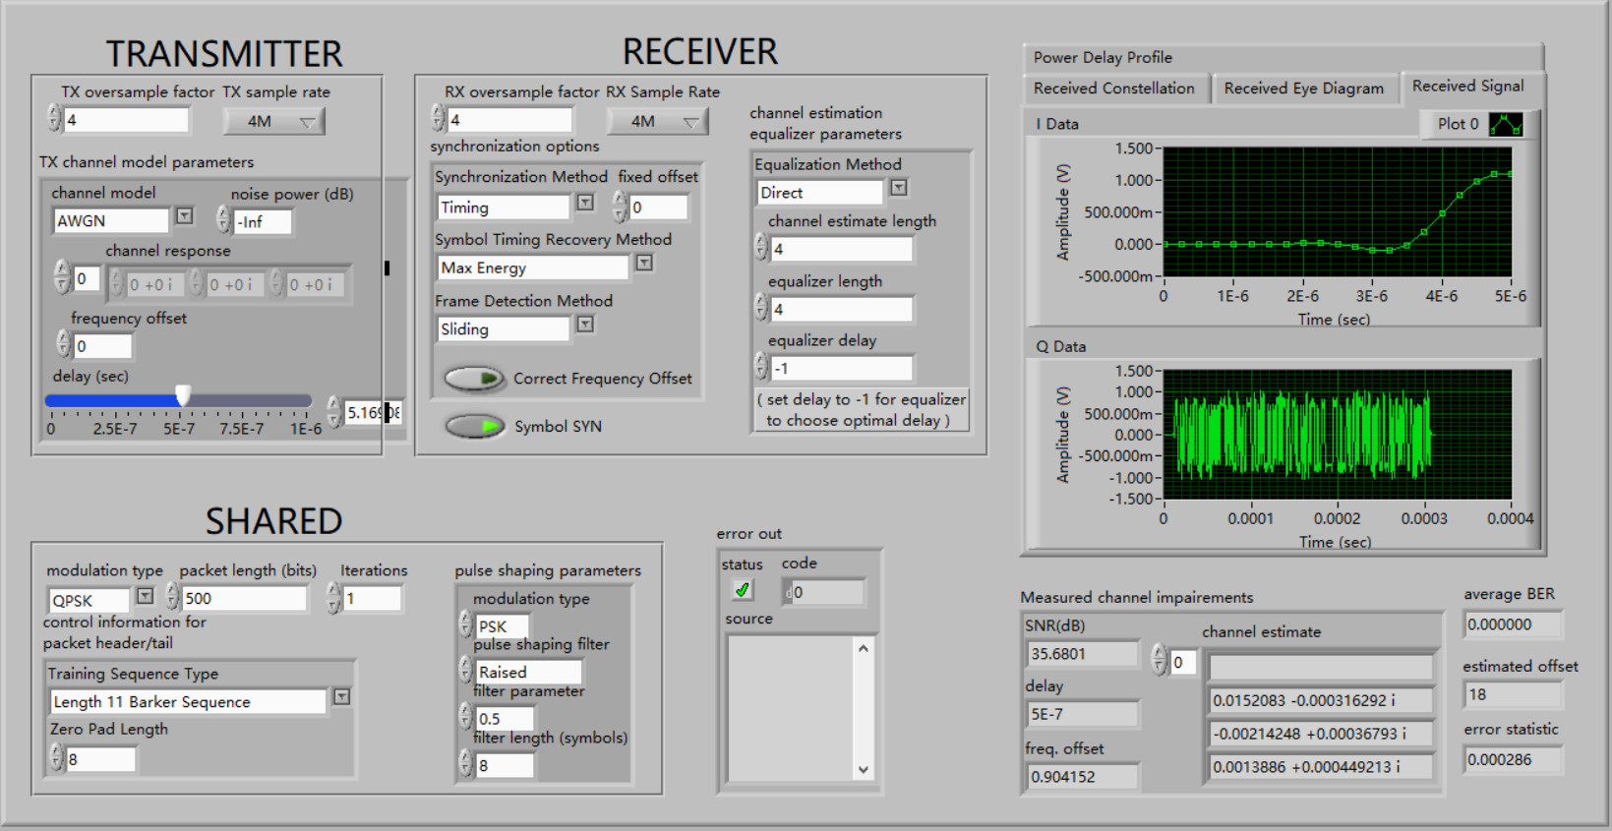

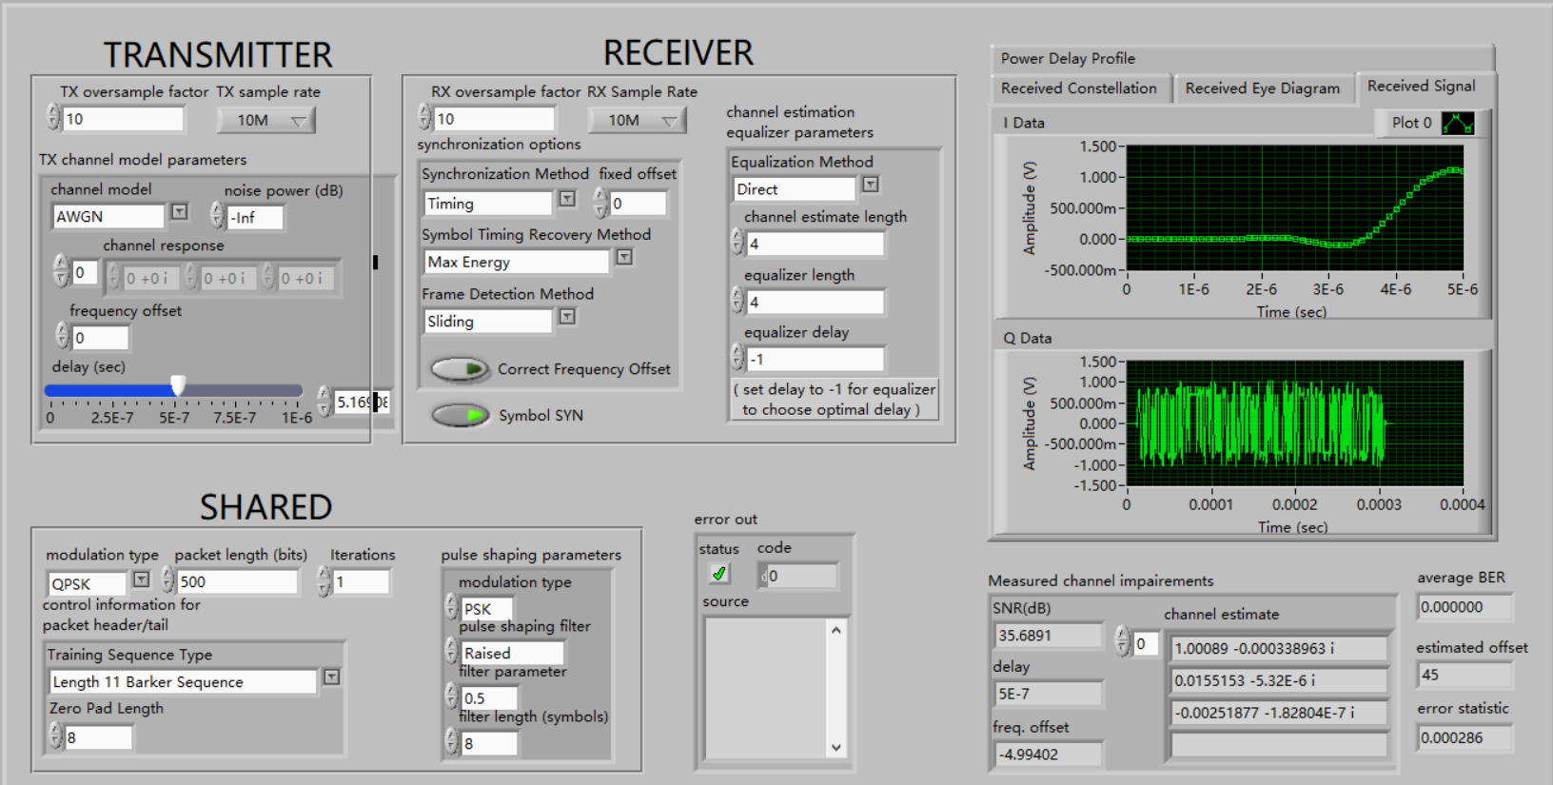

The period of symbol synchronization is:

$$T=\frac{4}{4M}=\frac{10}{10M}=1μs \text{(10)}$$

Next, trend of symbol synchronization accuracy with the change of oversample factor will be discussed when the period of sampled signal is fixed.

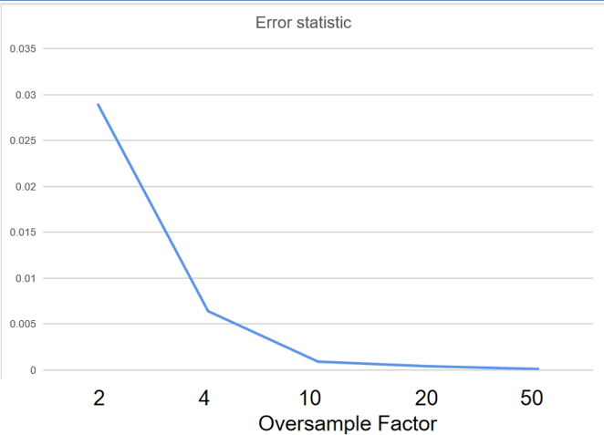

image-20221030110138563

With the oversample factor increasing, the error statistic become smaller and smaller, which is correct according to the analysis.

## Experience

1. Understanding of basic principle of symbol synchronization
2. Master of Maximum Energy Algorithm and understanding of Early-Late Gate Algorithm
3. Master of programming of Maximum Energy Algorithm

### In-class submission

张旭东：

